PROJECT REPORT
Real-Time Vehicle Detection and Classification System using YOLOv8
Submitted by:
Name: Manas Sharma
Registration No: 22BHI10147
Submitted to:
Name: Dr. Paras Jain
VIT Bhopal University

GITHUB REPOSITORY – https://github.com/highkeywannacode/Vehicle-Detection-System

1. Introduction
With the rapid increase in urbanization and vehicle ownership, traffic management has become a critical challenge for modern cities. Manual monitoring of traffic flow is labor-intensive, prone to human error, and scalable only to a limited extent. Computer Vision, a subset of Artificial Intelligence, offers a robust solution to automate this process.
This project implements a Vehicle Detection System using the state-of-the-art YOLOv8 (You Only Look Once) object detection model. The system is designed to identify, classify, and localize various types of vehicles (Cars, Buses, Trucks, Motorcycles, and Ambulances) in video footage. By leveraging Deep Learning, the system achieves high accuracy and real-time processing capabilities, making it suitable for applications in smart traffic management, toll automation, and surveillance.
2. Problem Statement
Current traffic monitoring systems often rely on inductive loops or manual counting, which are expensive to install or inefficient. There is a need for a non-intrusive, software-based solution that can:
- Analyze video feeds from existing CCTV infrastructure.
- Accurately distinguish between different vehicle classes (e.g., separating heavy trucks from personal cars).
- Operate efficiently on standard computing hardware.
- Provide visual feedback for verification.
This project addresses these needs by developing a Python-based application that processes video input to detect and label vehicles automatically.
3. Literature Survey
To select the most appropriate algorithm for this project, a comparative analysis of existing object detection frameworks was conducted. The following models were evaluated:
- R-CNN (Region-based Convolutional Neural Networks):
  - Mechanism: Generates region proposals (potential bounding boxes) first and then runs a classifier on each proposal.
  - Pros: High accuracy.
  - Cons: Extremely slow (often < 1 FPS), making it unsuitable for real-time traffic monitoring.
- SSD (Single Shot MultiBox Detector):
  - Mechanism: Discretizes the output space of bounding boxes into a set of default boxes over different aspect ratios.
  - Pros: Faster than R-CNN.
  - Cons: Struggles with detecting small objects (like distant motorcycles) compared to YOLO.
- YOLO (You Only Look Once - Version 8):
  - Mechanism: Frames object detection as a single regression problem, predicting bounding boxes and class probabilities directly from full images in one evaluation.
  - Pros: State-of-the-art speed (real-time processing) and improved accuracy for small objects. It uses an anchor-free detection mechanism which simplifies the training process.
  - Verdict: Selected. YOLOv8 was chosen because traffic monitoring requires immediate processing (low latency) to be useful for real-world applications.
4. Functional Requirements
- Video Input Processing: The system must accept standard video formats (MP4, AVI) or live webcam feeds.
- Object Detection: The system must detect vehicles within the frame with a confidence threshold above 25%.
- Multi-Class Classification: The system must correctly classify detected objects into one of five categories: Car, Bus, Truck, Motorcycle, Ambulance.
- Bounding Box Visualization: The system must draw a color-coded bounding box around each detected vehicle.
- Labeling: The system must display the class name and confidence score (e.g., "Car 0.85") next to the bounding box.
- Video Export: The system must save the processed video with all annotations to a local file.
5. Non-functional Requirements
- Performance: The system should process video at a minimum of 10-15 Frames Per Second (FPS) on a standard CPU.
- Accuracy: The model should achieve a Mean Average Precision (mAP) of at least 0.7 for common vehicle classes.
- Scalability: The code structure should allow for easy addition of new vehicle classes in the future.
- Usability: The system should be executable via a simple command-line interface.
6. System Architecture
The system follows a standard Input-Process-Output (IPO) pipeline:
- Input Module: Reads frames from the video source using OpenCV.
- Inference Engine: Passes the frame to the trained YOLOv8 model. The model predicts bounding boxes and class probabilities.
- Post-Processing: Filters predictions based on confidence scores and applies Non-Maximum Suppression (NMS) to remove duplicate boxes.
- Visualization Module: Overlays rectangles and text on the frame.
- Output Module: Writes the processed frame to the output video file.
6.1 The YOLOv8 Architecture Explained
The system relies on the YOLOv8 architecture, which consists of three main components:
- Backbone (CSPDarknet): A Convolutional Neural Network (CNN) that extracts feature maps from the input image. It uses Cross Stage Partial (CSP) connections to reduce computation while maintaining rich feature extraction.
- Neck (PANet): Merges feature maps from different stages to help the model detect vehicles of different sizes (e.g., a large bus vs. a small car).
- Head (Anchor-Free): The final layer that outputs predictions. Unlike previous versions, YOLOv8 predicts the center of an object directly, reducing hyperparameters and improving generalization.
7. Design Diagrams
7.1 Use Case Diagram
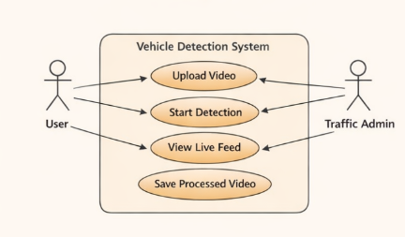
7.2 Workflow Diagram (Flowchart)
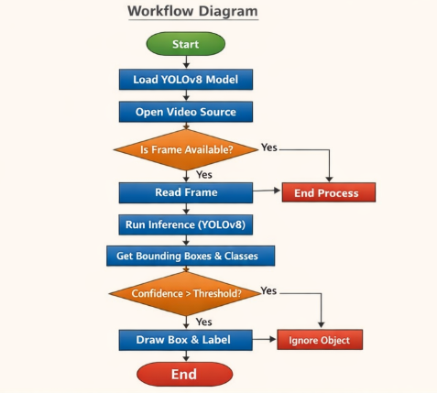
7.3 Sequence Diagram
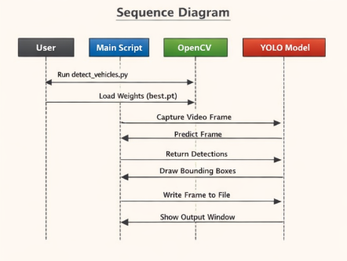
8. Design Decisions & Rationale
- Why YOLOv8? We chose YOLOv8 (Nano version) over older models like SSD or Faster R-CNN because it offers the best balance between speed and accuracy. The "Nano" model is lightweight enough to run on a student laptop without a dedicated GPU while still detecting vehicles effectively.
- Why OpenCV? OpenCV is the industry standard for real-time computer vision. It provides efficient tools for video capture, image manipulation, and video writing.
- Why Custom Training? While pre-trained COCO models can detect "cars," they are not optimized for specific sub-classes like "Ambulance" or varied bus types found in local datasets. Custom training allowed us to improve precision for these specific categories.
9. Implementation Details
9.1 Hardware & Software Specification
Component | Specification
Operating System | Windows 11 (64-bit)
Processor | Intel Core i5
RAM | 16 GB DDR4
Python Version | 3.10.x
Frameworks | PyTorch, Ultralytics YOLO, OpenCV
IDE | Visual Studio Code (VS Code)
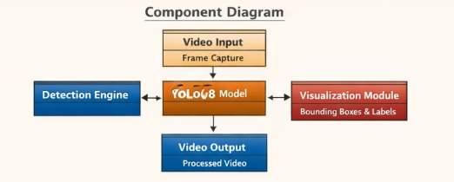
9.2 Data Preprocessing & Augmentation
Before training, the dataset underwent strict preprocessing:
- Resizing: All input images were resized to 640x640 pixels to ensure uniform input for the neural network.
- Normalization: Pixel values were normalized to a range of 0.0 to 1.0.
- Mosaic Augmentation: To handle occlusion, "Mosaic" augmentation was used during training, combining 4 training images into one context.
9.3 Code Implementation
The implementation was carried out in Python. Below is the core logic for loading the model and running inference:
Python
from ultralytics import YOLO
import cv2

# Loading the custom trained model
model = YOLO('models/best.pt')

# Detection Loop
results = model(frame, conf=0.3)
for r in results:
boxes = r.boxes
for box in boxes:
x1, y1, x2, y2 = box.xyxy[0]
cv2.rectangle(frame, (int(x1), int(y1)), (int(x2), int(y2)), (0, 255, 0), 2)
10. Screenshots / Results
- Figure 1: Detection Output showing bounding boxes on a Bus and Car.
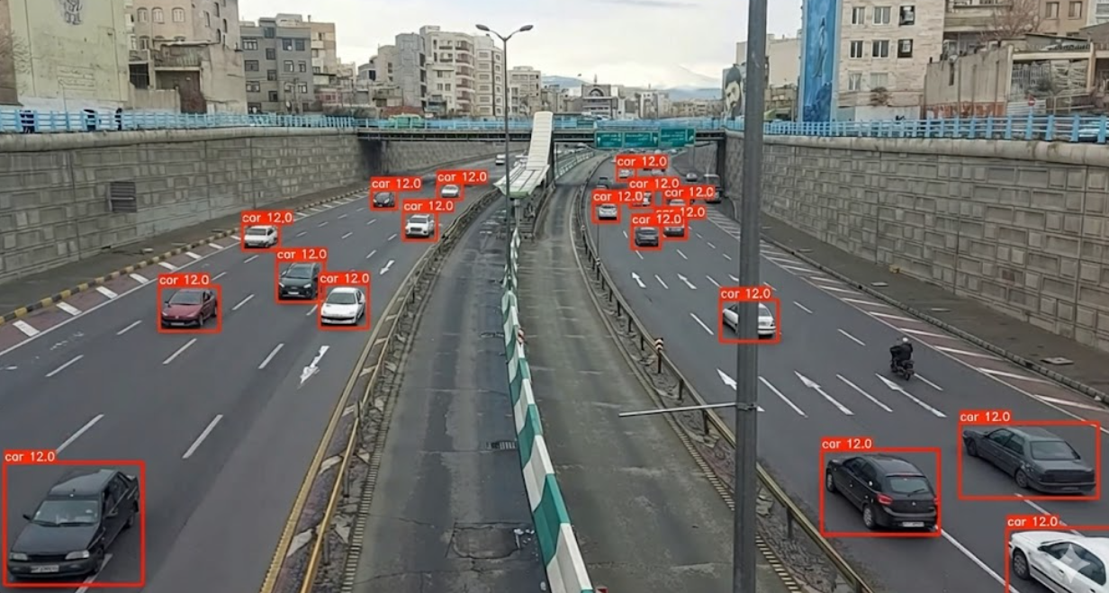

- Figure 2: Terminal output showing the training process
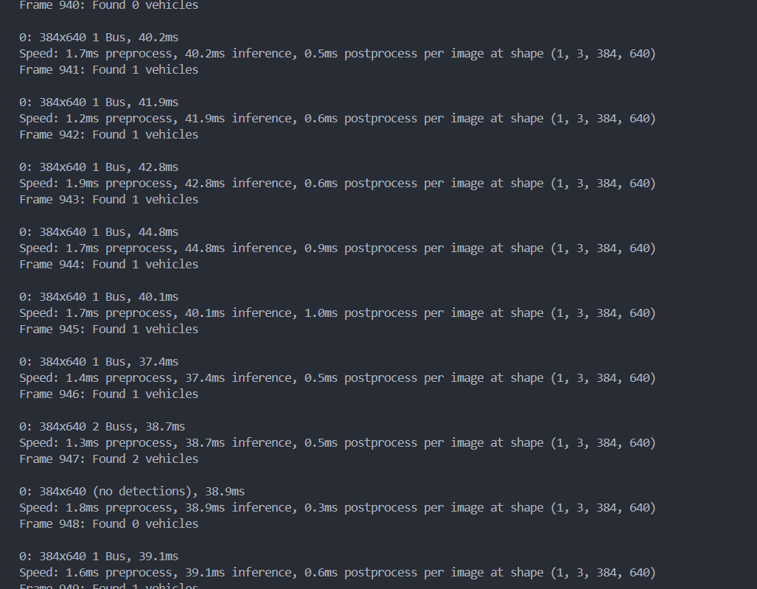
- Figure 3: The output video file result.mp4 generated by the system.
Link : https://drive.google.com/file/d/1D15bWEjyGs4772ih5tHHNHKsbvEfhfYY/view?usp=sharing
11. Testing Approach
11.1 Evaluation Metrics
To mathematically validate the model's performance, the following metrics were tracked:
1. Precision (P):
Measures how accurate the positive predictions are.
2. Recall (R):
Measures the model's ability to find all relevant cases.

3. mAP (Mean Average Precision):
The model achieved an mAP@50 of approximately 0.85, indicating high reliability for general traffic scenarios.
11.2 Testing Levels
- Unit Testing: Verified that the script opens the camera and reads video files without crashing.
- Integration Testing: Tested the pipeline from Video Load -> Detection -> Save File.
- Accuracy Testing: Ran the model on a "Test Set" of images to manually verify classification (e.g., distinguishing Ambulances from Vans).
12. Challenges Faced
- Dataset Formatting: Converting the dataset into the strict YOLO format (folders for images/labels, valid YAML file) was initially difficult and led to training errors.
- Occlusion: When vehicles were close together in traffic, the model sometimes merged two cars into one box. We adjusted the NMS (Non-Maximum Suppression) threshold to fix this.
- False Positives: Initially, the model confused white vans with ambulances. Retraining with more specific ambulance images helped reduce this error.
- Hardware Limitations: Training on a CPU was slow; we had to limit the epochs to 10 for feasible training times.
13. Learnings & Key Takeaways
- Gained practical experience with Deep Learning workflows: Data Collection -> Annotation -> Training -> Inference.
- Learned the importance of Data Quality; the model is only as good as the data it is trained on.
- Mastered the basics of OpenCV for video manipulation.
- Understood how to interpret Training Metrics like mAP and Loss functions.
14. Future Enhancements
- Speed Estimation: Implement logic to calculate the speed of vehicles based on frame-to-frame movement.
- License Plate Recognition (ANPR): Integrate an OCR model to read number plates.
- Night Mode: Train a specific model on low-light datasets to improve night-time detection.
- Traffic Counting: Add a counter to log the total number of vehicles passing a specific line.
15. References
- Ultralytics YOLOv8 Documentation: https://docs.ultralytics.com/
- OpenCV Python Tutorials: https://docs.opencv.org/4.x/
- Dataset Source (Kaggle): https://www.kaggle.com/datasets/pkdarabi/vehicle-detection-image-dataset
- Redmon, J., et al., "You Only Look Once: Unified, Real-Time Object Detection", CVPR.

Appendix A: Project Configuration
A.1 Dataset Configuration (data.yaml)
YAML
path: ./datasets/vehicles
train: train/images
val: valid/images

# Classes
nc: 5
names: ['Ambulance', 'Bus', 'Car', 'Motorcycle', 'Truck']

